CmpE 110 LAB 1 Dr. A. Bindal

FIRST-ORDER PASSIVE CIRCUITS

Part 1: RC Circuits

(a) Using the resistor values, R = 1KΩ, 10KΩ, 100KΩ and 1MΩ, calculate the capacitor values for a time constant value of 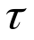= 1 µs for each resistor.

(b) Use each RC combination from part (a) in the circuits below and measure the rise time and the fall time at the output, vout. You need to add a pulse generator option from the LTSPICE database that changes between 0 and 5V at the input of the circuit, and observe the circuit response at the output terminal. Note that the rise time is measured from 20% of the output voltage to 80% of the output voltage. Similarly, the fall time is measured from 80% of the output voltage to 20% of the output voltage.

(c) Use each RC combination from part (a) in the circuits below and find the time constant. Use the mathematical expressions of vout for each circuit to extract the time constant, and then use the measured time and voltage values from your Spice simulations to determine the time constant.

Show the calculated and measured rise and fall times and time constants in an Excel table and explain the error between the measured and calculated values.
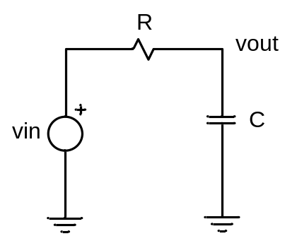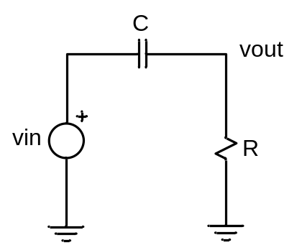

Part 2: RL Circuits

(a) Using the resistor values, R = 1KΩ, 10KΩ, 100KΩ and 1MΩ, calculate the inductor values for a time constant value of = 1ns in each case.

(b) Use each RL combination from part (a) in the circuits below and measure the rise time and the fall time at the output, vout. You need to add a pulse generator option from the LTSPICE database that changes between 0 and 5V at the input of the circuit, and observe the circuit response at the output terminal.

(c) Use each RL combination from part (a) in the circuits below and find the time constant. Use the mathematical expressions of vout for each circuit to extract the time constant, and then use the measured time and voltage values from your Spice simulations to determine the time constant.

Show the calculated and measured rise and fall times, and time constants in an Excel table and explain the error between the measured and calculated values.

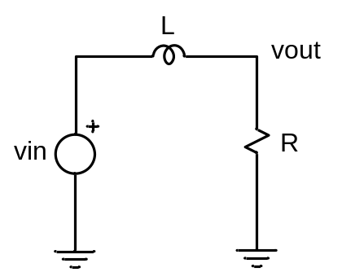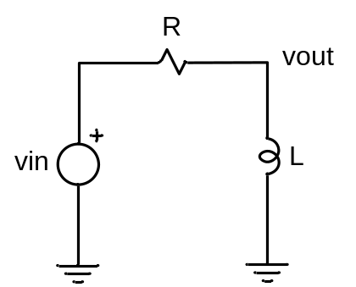

SECOND-ORDER PASSIVE CIRCUITS

A series RLC circuit is given below. The output voltage is observed across a capacitor with an oscilloscope while input voltage changes between 0 V and 5 V using a pulse generator.
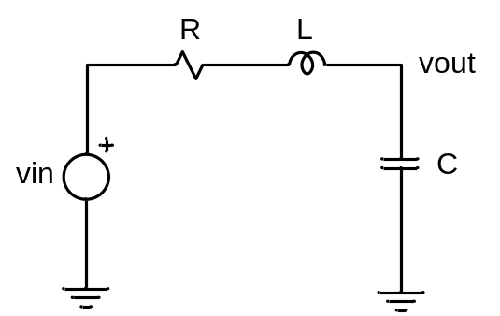

Considering the output voltage of this circuit has two roots (at this point please refer to your notes and the book),

s1 = 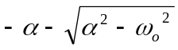
s2 = 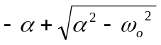

- Calculate L such that the oscillation angular frequency, 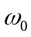, is 10⁷rad/sec if C = 100pF is used in the circuit above.

- Use the values of C = 100pF and the value of L determined in part (a), construct separate RLC circuits with R = 0Ω, 10Ω, 100Ω, 1KΩ, 10KΩ. In each case, compute the real and imaginary parts of s1 and s2. Tabulate your results in an Excel table.

(c) Apply the pulse generator at vin terminal that changes between 0 and 5V to each RLC circuit in part (b), and measure the rise and fall times at vout with LTSPICE waveform cursors. Make sure to adjust your pulse width large enough such that the output voltage settles at a certain value before taking measurements. Tabulate your results in an Excel table.

- Apply the pulse generator at vin that changes between 0 and 5V, and measure the time constant (if applicable) at vout for each RLC circuit in part (b) with LTSPICE waveform cursors. Tabulate your results in an Excel table.

- Apply the pulse generator at vin that changes between 0 and 5V, and measure the free oscillation frequency, f₀ = ω₀/2π, (if applicable) at vout for each RLC circuit in part (b) with LTSPICE waveform cursors. Tabulate your results in an Excel table.

It is critical to explain your results and the error between the measured and calculated values in your report.

